2019 Second-Quarter Newsletter

What We Do at Not Alone Blind Internet Ministry:
- Provide a weekly devotional podcast message called “You’re Not Alone”
- Provide a Bible study podcast called “Room 4216”
- Serve 52 Outreach Centers with a newsletter and leadership support
- Provide pastoral care and counseling that comes from podcasts listeners
- Raise financial support and awareness for Not Alone Blind Internet Ministry

Thank you for your prayers and support. It is through you that God meets the needs of this mission.

As you read this newsletter, the signs of spring and new life are clear: flowers are coming up and blooming; trees are greening out; summer birds are returning and building nests; refreshing rains are fostering new growth. In a similar way, the signs of God’s love and care are evident as well: His Word is read and heard; His Word is changing hearts and lives; His Word is strengthening faith; His Word is expanding His kingdom.

Devotional Thought: New Life, New Hope

“God, pick up the pieces. Put me back together again. You are my praise!” (Jeremiah 17:14 The Message)

It was cloudy, cold, and snowy here in the Midwest this past winter! I must admit, as winter ended, I felt emotionally down and unmotivated. Cloudy days clouded my mind. Perhaps some of you also experience seasonal affective disorder, like I do. Yet ministry—whether blind ministry or any other Christian ministry—is God’s. He is not only in charge but also supplies all that is needed for ministry and for us personally. I am thankful that I am His and that this ministry is His as well.

As I look back on the first three months of this year, I can see God’s hand at work in my life, in my family, and in this blind ministry. Podcasts were produced, sent out, and listened to; Outreach Centers and their leaders were encouraged and prayed for; individual people who are blind were encouraged and strengthened.

I must say, though, that it was God at work, not me. May we all be amazed as we see God picking up the broken pieces of our lives and using them to share His Gospel with others.

Pastor Dave Andrus
Celebrating 20 Years of Ministry: The Pittsburgh Outreach Center for the Blind

Besides the podcasts, Pastor Dave also encourages, supports, and helps the Outreach Centers for the Blind. In March, the Pittsburgh Outreach Center for the Blind celebrated 20 years of serving the blind community. Hundreds of blind people have been blessed through this Outreach Center. Not only was this the first Outreach Center but it has also served in a variety of different ways:
- Teaching Braille
- Teaching how to use computers with speech output
- Offering guide-dog support groups
- Holding classes to deal with depression
- Providing a monthly meal for food and fellowship

The Pittsburgh Outreach Center invited Bob Mates, its first blind director, and Pastor Dave to attend its 20 years of celebration. They shared their greetings and encouragement to continue to share and show God’s love.
Sherri Crum, the current Outreach Center blind leader, reported that a few folks came back who had not been there for years. They reconnected to the Outreach Center, knowing that they would be accepted. At times, life detours us for a bit, but the Outreach Center always offers open arms. This reflects God’s constant, steady love.

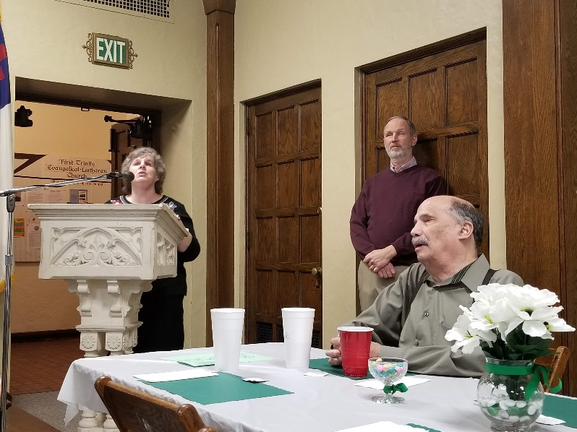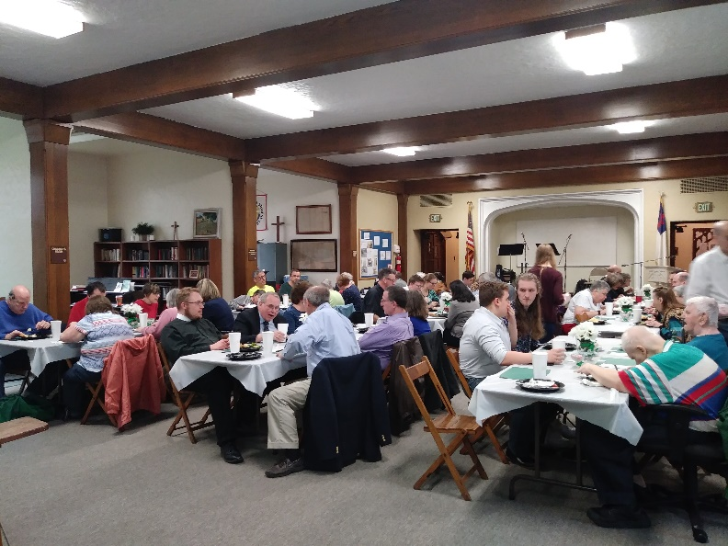
Sherri Crum, Pastor Dave, Bob Mates Celebrating 20 years—Pittsburgh Outreach Center Banquet

Please continue partnering with Not-Alone Blind Internet Ministry to provide hope and restore comfort to those who are blind. You can donate online at www.not-alone.net and click on the “GIVE” button at the bottom of the page or send a check to this address:

Blind Ministry
Abiding Savior Lutheran Church
4355 Butler Hill Road
St. Louis, MO 63128

